Virginia DOLI Consultation  Services  To help small employers better understand and voluntarily comply with VOSH standards we offer FREE consultation services.  What we offer:  - On-site visits  - Training  - Abatement Advice  - Program Assistance  Schedule our services:  - www.doli.virginia.gov  - Main Street Centre  600 East Main Street, Suite 207  Richmond, Virginia 23219  - Phone: 804.371.2327  Fax: 804.371.6524  - consultation@doli.virginia.gov |  | Virginia Department Of Labor and Industry  600 East Main Street, Suite 207  Richmond, Virginia 23219 | Recipient Name  Address  City, ST ZIP Code | www.doli.virginia.gov  consultation@doli.virginia.gov  Phone: (804) 371-2327  Fax (804) 786-8418 | Virginia Department of Labor and Industry  Consultation Services  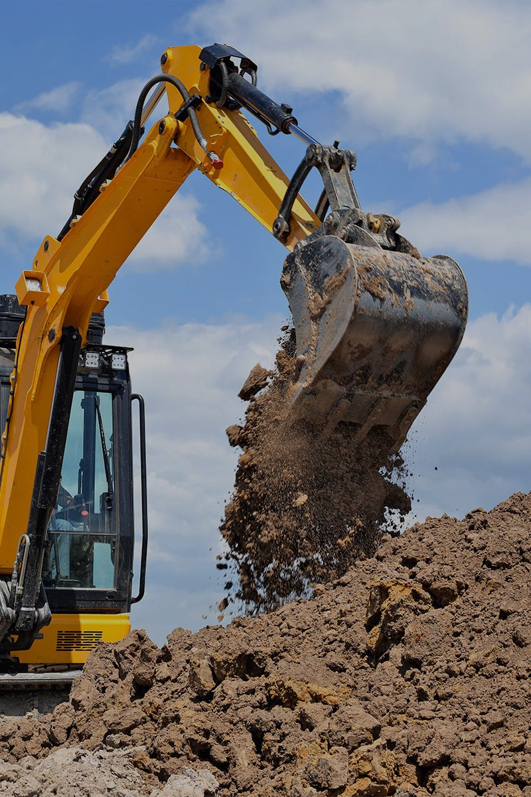  Trenching and Excavation

Employee Protection  Cave-In Protection  Trenches that are 5 feet deep or greater require the use of a protective system. Here are three ways to protect your employees from potential trench/excavation cave-ins:  - Sloping and benching the sides of the excavation  - Support both sides of the excavation  - Place shields or trench boxes between the sides of the excavation and work area  Safe Work Practices  - Ensure safe Entry and Exits  - Keep spoil piles 2 feet away or more from the trench  - Be aware of standing or accumulating water  - Never work under suspended loads  - Never enter a trench that has not been inspected by a competent person | Competent Person  OSHA defines a competent person as “one who is capable of identifying existing and predictable hazards in the surroundings or working conditions which are unsanitary, hazardous, or dangerous to employees, and who has authorization to take prompt corrective measures to eliminate them"  Responsibilities of a Competent Person  - Daily Inspections before work begins  - Re-inspecting the site when conditions change  - Soil classification (See 1926 Subpart P Appendix A)  - Ensure adequate protective systems are in place  - Remove employees from hazards  - Examine damaged protective systems  - Design structural ramps  - Monitor water levels and water removal equipment | DID YOU KNOW?  - an average of 25 employees die each year due to trenching and excavation cave-ins  - cave-ins usually occur with no warning  - one cubic yard of soil can weigh as much as a car  - A person trapped in a cave-in has little chance of survival

